My advisor MiEA 4.0
MiEA (My Invest EA) is a multi-currency Expert Advisor that simultaneously controls 9 pairs from one window.
He has a wide choice of settings, as well as a trading panel for manual work, or adjusting the work if necessary.
In earlier versions, different, different algorithms were used, but we will focus on version 4.0, the most recent
version.
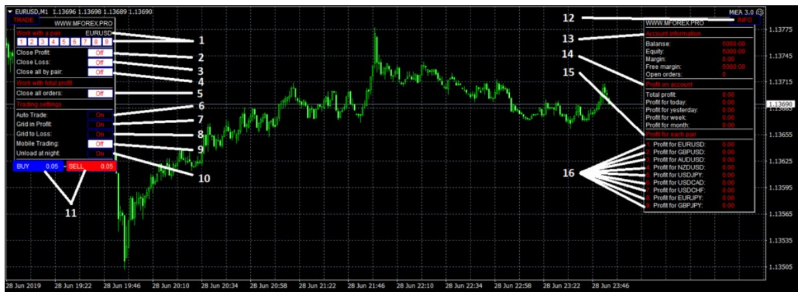
1. Choosing a pair for work. You can see in the INFO panel at the bottom, there are numbers of each pair (16),
to select the one you need, just press the button with the desired pair number and start working. Of the
possibilities are: Open order (11), close all orders for the selected pair (4), close only orders that are in positive
(2), close only orders that are at a loss (3). By default, the pair is not selected, work with the pair on which the
adviser is installed.
2. The button that is responsible for closing all positive orders for the selected pair (1).
3. The button that is responsible for closing all negative orders for the selected pair (1).
4. The button that is responsible for closing all orders for the selected pair (1).
5. The button that is responsible for closing all orders that the adviser opened in all nine pairs. In other words,
the emergency button«CloseAll».
6. Button on / off auto trade. In order to go completely into manual control, it is sometimes necessary to disable
the algorithm for opening deals by an advisor, this is what this button is made for. When you turn off the auto
trade button, the entire functionality of the adviser will work, but it will not open initial orders, nor will they close
them when a profit is reached. When disconnected, the percent continues to work.
7.Button on / off the accumulation of orders if the price goes in the direction of the initial entry. Each new entry is
made if there was a repeated signal, if the pair has a profit greater than zero, if there is a specified step between
the new and the last
8. Button to enable / disable accumulation of orders if the price goes in the opposite direction from the initial
entry. Each new entry is made if there was a repeated signal, if there is not a single profitable order, if there is a
specified step between the new and the last order.
9. Button to enable / disable trading with the MT4 mobile terminal. Many traders who work with advisors or
trading systems are faced with the fact that there is no possibility of quickly and comfortably controlling the work
of an advisor remotely from a mobile terminal. For example, close all orders by pair, or all orders on the account
with one click of a button, or initiate a grid of orders in the desired direction by the desired pair. In MiEA it is
implemented.
Opportunities:
— To set the direction of trade (open the first starting order), it is enough to make sure that the adviser does not
have any orders for this pair and open an order with any lot (preferably with a minimum) in the right direction. At
the same time, the adviser will open his order in this direction and continue to conduct a series of orders as his
own.
— To close all orders for the desired pair, it is enough to open an order with any lot (preferably with a minimum)
for the desired pair in the opposite direction from the direction of trading advisor. That is, if the adviser is
conducting a series, for example, SELL, then a BUY order is opened from the mobile terminal for the same pair,
the adviser will take it as a signal to close all orders for this pair.
— To close all orders of the adviser on all pairs at the same time, it is enough to open an order in any direction
according to the pair specified in the settings for closing. The parameter that is responsible for selecting a pair in
the settings is displayed as MobClosPair and, by default, is set to EURAUD. That is, if you need to close all
orders, an order is opened in the mobile terminal in any direction for the EURAUD pair, the adviser will take this
as a signal to close all orders.
10. Button to enable / disable closing profitable overnight orders. In the MiEA adviser there are settings for
working hours in hours. The default is from 02:00 to 22:00 terminal time. If the unloading button for the night is
turned on, then when the TimeEnd is reached (22:00), the adviser will close all profitable orders, thereby
dropping the trading volume and freeing the margin, before switching to the new day and as is usually the case,
expanding the spread.
11. Buttons BUY, SELL. Made for manual opening orders. The lot is set as a risk in the settings of the adviser
and displayed on the buttons so that the user understands with which lot the order will be opened.
12. Button on / off panel INFO. It often happens that the panel is blocking the part of the graph that is necessary
for the analysis; to do this, simply press the button and the panel will be minimized. When you press it again, the
panel will be displayed again. I do not advise in the same way to disable the TRADE panel, as in this case, the
adviser will not see the panel settings.
13. Block information panel which displays account data. Balance, funds, margin, free margin, how many
transactions the adviser opened in total.
14. Statistical Profit Block. Here you can see what the current profit or how much the adviser has earned earlier.
15. A block that displays the current profit for each pair separately.
Description of parameters:
Languale …………………………… Choosing the language in which the panels will be displayed
Risk …………………………………… Risk in percent of the balance per order
StopLossProcent ……………… Stop as a percentage of balance
PEURUSD …………………………. The name of the pair. Write as displayed in the terminal
PipsStep_1 ……………………… .. Responsible for the frequency and accuracy of inputs. Less value, more
orders
pEURUSD_StepM …………… Step between orders for the grid in minus
pEURUSD_StepP ……………. Step between orders for the grid plus
pGBPUSD …………………………. The name of the pair. Write as displayed in the terminal
PipsStep_2 ………………………. Responsible for the frequency and accuracy of inputs. Less value, more orders
pGBPUSD_StepM …………… Step between orders for the grid in minus
pGBPUSD_StepP ……………. Step between orders for grid plus
pAUDUSD ……………………… ..Name of the pair. Write as displayed in the terminal
PipsStep_3 ………………………. Responsible for the frequency and accuracy of inputs. Less value, more orders
pAUDUSD_StepM ………….. Step between orders for the grid in the minus
pAUDUSD_StepP …………… Step between orders for plus grid
pNZDUSD ……………………… ..Name of the pair. Write as displayed in the terminal
PipsStep_4 ……………………… Responsible for the frequency and accuracy of inputs. Less value, more orders
pNZDUSD_StepM ………… ..Step between orders for the grid in the minus
pNZDUSD_StepP …………… Step between orders for plus grid
pUSDJPY …………………………. The name of the pair. Write as displayed in the terminal
PipsStep_5 ……………………… Responsible for the frequency and accuracy of inputs. Less value, more orders
pUSDJPY_StepM …………… Step between orders for the grid in minus
pUSDJPY_StepP ……………. Step between orders for the grid plus
pUSDCAD ……………………… ..Name of the pair. Write as displayed in the terminal
PipsStep_6 ………………………. Responsible for the frequency and accuracy of inputs. Less value, more orders
pUSDCAD_StepM ………….. Step between orders for the grid in the minus
pUSDCAD_StepP …………… Step between orders for grid plus
pUSDCHF ……………………… ..Name of the pair. Write as displayed in the terminal
PipsStep_7 ………………………. Responsible for the frequency and accuracy of inputs. Less value, more orders
pUSDCHF_StepM ………… ..Step between orders for the grid in the minus
pUSDCHF_StepP …………… Step between orders for plus grid
PEURJPY ……………………… ..Name of the pair. Write as displayed in the terminal
PipsStep_8 …………………… .. Responsible for the frequency and accuracy of inputs. Less value, more orders
pEURJPY_StepM ………… ..Step between orders for the grid in the minus
pEURJPY_StepP …………… Step between orders for plus grid
pGBPJPY ……………………… ..Name of the pair. Write as displayed in the terminal
PipsStep_9 ……………………. Responsible for the frequency and accuracy of inputs. Less value, more orders
pGBPJPY_StepM ………… .Step between orders for the grid in the minus
pGBPJPY_StepP ………… ..Step between orders for plus grid
MobClosPair …………………. Name of the pair for closing orders via mobile terminal MT4
TimeStart …………………… ..The start time. Measured in hours
TimeEnd ……………………… .The end time. Measured in hours
MaxOrders ……………………. Maximum number of all orders
Magic …………………………… .Marker orders advisor
Installation
The Expert Advisor is installed in only one window of the EURUSD pair, M1 timeframe. For stable work you
need a deposit of $ 500 (better from $ 1000) and a lever of 1: 500. MiEA 3.0 works only with quotes of 5
characters.
MiEA 4.0 trading algorithm / changes
Entry point and order tracking completely changed. In the current version, the adviser is fully trend. To determine
the entry point, it searches for a series of price impulses in one direction, after which it determines the micro
trend and opens the initial order in that direction. In the MiEA 4.0 version, the goal of order tracking is not just the
accumulation of the grid, but the accumulation of position only behind the trend. The step of accumulating a
position behind the trend is small, while against the trend is very large. In other words, now the adviser
accumulates only profit, the loss does not accumulate. Also in this version, a stop is added as a percentage of
the balance to fix losses. Increased profitability by increasing the risk-to-profit ratio. It used to be 1/11 of risk,
now 1/4 for each pair. Increased profitability by implementing the fixation of all profitable orders when you enable
unloading at night. The remote control of the adviser using the MT4 mobile terminal has been implemented.
Results / Plans
The MiEA EA (My Invest EA) is being developed from 2016 and continues to evolve. The results from the very
beginning and still surprise many traders.
Link to monitoring MyfxBook
The plans in the near future to release a version with fewer orders. I would like to separate strongly volatile pairs,
leave 5-6 pairs, with the smallest amplitude of movement.

